Project Design Phase
Solution Architecture
Date | 01 October 2026
Team ID | [Enter your Team ID]
Project Name | Blog Nest – AI-Powered Blogging & Content Management Backend
Maximum Marks | 4 Marks

Solution Architecture:
Solution architecture bridges the gap between business problems and technology solutions. For Blog Nest its goals are to:
- Find the best technical solution for managing blogs securely with AI support.
- Describe the structure and behaviour of the system to project stakeholders.
- Define features, development phases and solution requirements.
- Provide specifications according to which the solution is built, tested and delivered.
Architecture Overview
Blog Nest follows the MVC pattern: Mongoose schemas form the Model layer, controllers apply business rules and call the AI service, and the API route network acts as the View layer because the system is headless. Every protected request passes through JWT verification, role-based authorization, sanitization and rate limiting before reaching a controller.
Solution Architecture Diagram:
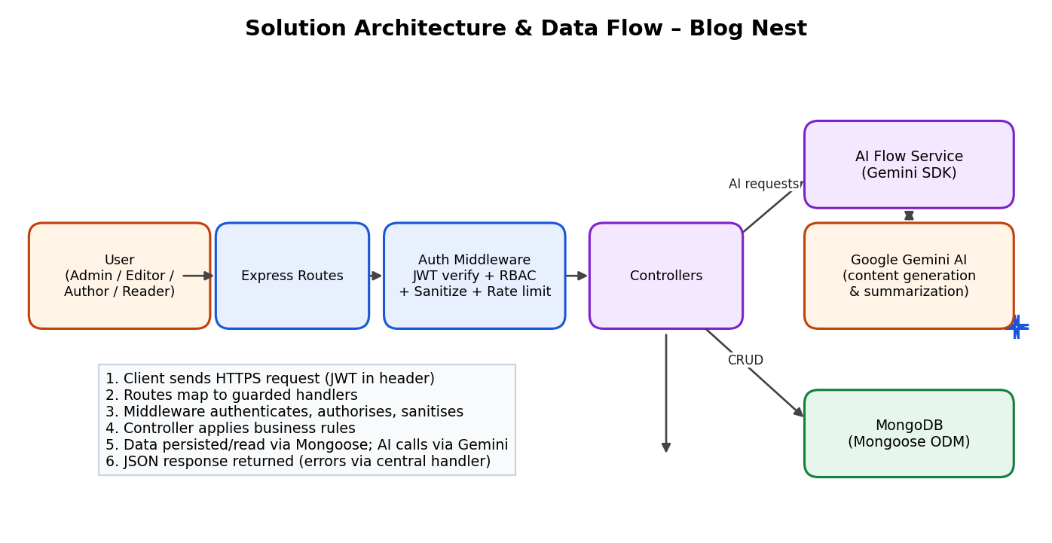
Figure 1: Architecture and data flow of Blog Nest
Key Design Decisions
Area | Decision
Architecture style | Stateless REST API with modular MVC (models, controllers, routes, middleware).
Security | JWT tokens, bcrypt hashing, RBAC for four roles, sanitization, rate limiting.
Data | MongoDB with Mongoose; one-to-many relations: User → Posts and Post → Comments.
AI integration | Dedicated AI Flow service wraps the Google Gemini SDK for blog generation and summarization.
Reliability | Centralized error-handling middleware and structured logging.

